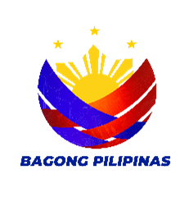
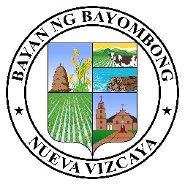


Republic of the Philippines
Province of Nueva Vizcaya
Municipality of Bayombong
ooOoo
BARANGAY LA TORRE NORTH
Provincial Road, La Torre North, Bayombong, Nueva Vizcaya Email: barangaylatorrenorthnuevvizcay@gmail.com Philippines, 3700 TEL#s - (078) 321-4745 / 392-1894 Contact Numbers: 0916-174-9428/0927-570-6819
FB Page: Barangay La TORRE NORTH
SANGGUNIANG BARANGAY

JOEL C. CASTRICIONES
Punong Barangay

BARANGAY KAGAWADS

MILAGROS P. PADILLA

VILLAFUERTE T. MARTINEZ JR.

MELITA P. SANCHEZ

IRENE C. BAJO

VIRGIL P. COVITA

CAROLINA V. VICENTE

JOSEPH P. ESTEBAN

SAMUEL JAMES B. DEL ROSARIO
SK Chairperson
BUSINESS CLEARANCE

BUSINESS CLEARANCE is hereby issued/granted to ERLINDA D. PALLAYA, proprietor/proprietress of SARI SARI STORE, to operate BUSINESS within this BARANGAY LA TORRE NORTH, BAYOMBONG, NUEVA VIZCAYA, effective this SEPTEMBER 02, 2025, to DECEMBER 31, 2025, of this year.

PROVIDED, however, that ordinances, rules & regulations regarding the operation of said business shall be observed and complied with.

ISSUED this 02nd day of SEPTEMBER, 2025 at Barangay La Torre North, Bayombong, Nueva Vizcaya.

BARANGAY CLEARANCE

TO WHOM IT MAY CONCERN:

THIS IS TO CERTIFY that ERLINDA D. PALLAYA, is known to be a peaceful, law-abiding citizen of good moral character and reputation.

RECORDS of this office show that there are no derogatory remarks against this citizen.

CERTIFIES FURTHER, that no pending case against this citizen was filed in this office.

THIS CLEARANCE is issued upon the request of the person mentioned above for whatever legal purpose/s it may serve.
ISSUED this 02nd day of September, 2025 at Barangay La Torre North, Bayombong, Nueva Vizcaya.

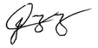
Certified By:

HON. JOEL C. CASTRICIONES
Punong Barangay NOTE: NOT VALID WITHOUT OFFICIAL SEAL
***** This is for a 1(one) single transaction only.

